**Issue 1:**

**Summary: Balance after Amount is showing wrong value. Its shows the Turn Over value.  
  
Steps to reproduce:  
  
URL: Localhost/...  
  
Test Environment:**

Browser: Chrome 85.0.4183.121 (Official Build) (64-bit)

Screen Size: 2560 x 1440  
OS: WIndows 10  
Device: Laptop

**Expected Result:  
  
Actual Results:͓  
  
  
Image:   
  
  
Video:  
  
Test Data: Example:**

|  |  |  |  |  |  |  |
| --- | --- | --- | --- | --- | --- | --- |
| **id** | **account_id** | **date** | **amount** | **currency** | **to_date_turnover_amount** | **to_date_turnover_currency** |
| 1 | 1 | 2020-08-31 19:51:20 | 100.000000 | EUR | 0.000000 | EUR |
| 2 | 1 | 2020-08-31 20:51:20 | -20.000000 | EUR | 100.000000 | EUR |
| 3 | 1 | 2020-09-01 21:51:20 | -10.000000 | EUR | 80.000000 | EUR |
| 4 | 1 | 2020-08-31 17:51:20 | -10.000000 | EUR | 170.000000 | EUR |

**Issue 2:**

**Summary: Previous date calculation is not working.**

**Steps to reproduce:  
  
URL: Localhost/...  
  
Test Environment:**

Browser: Chrome 85.0.4183.121 (Official Build) (64-bit)

Screen Size: 2560 x 1440  
OS: WIndows 10  
Device: Laptop

**Expected Result:  
  
Actual Results:͓  
  
Test Data:   
  
Image: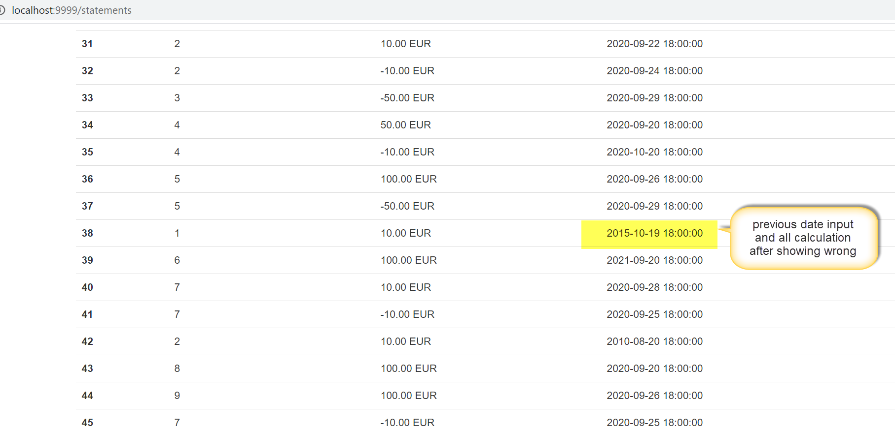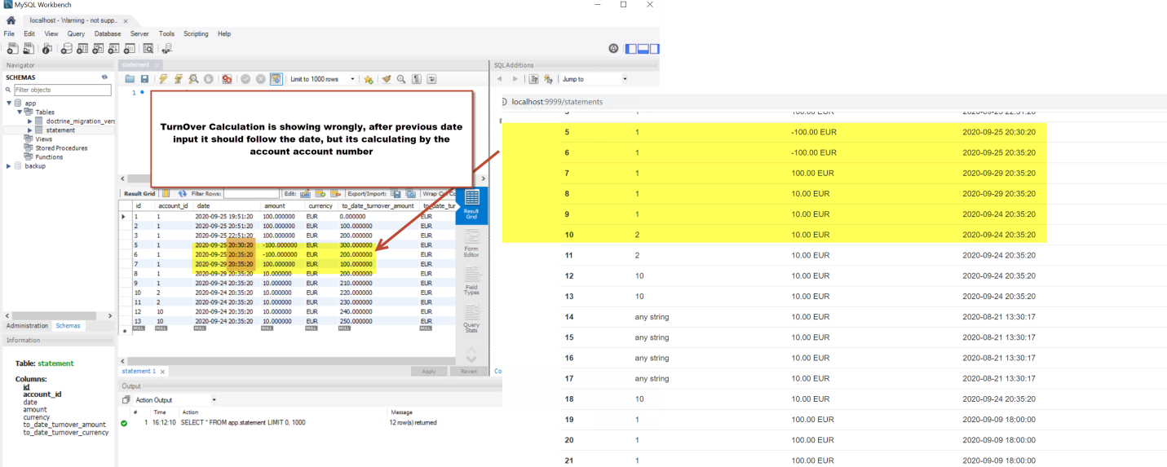 Video:**

**Issue 3:   
  
 Summary: Account specific amount is not calculating, it's only calculated sequentially.  
  
Steps to reproduce:  
  
URL: Localhost/...  
  
Test Environment:**

Browser: Chrome 85.0.4183.121 (Official Build) (64-bit)

Screen Size: 2560 x 1440  
OS: WIndows 10  
Device: Laptop

**Expected Result:  
  
Actual Results:͓  
  
Test Data:   
  
Image:   
  
  
Video:**

**Issue 4:   
  
 Summary: When all account details are showing in the statement page, Balance After and Balance Before are showing for representing which value?! It’s not meaningful!  
  
  
Steps to reproduce:  
  
URL: Localhost/...  
  
Test Environment:**

Browser: Chrome 85.0.4183.121 (Official Build) (64-bit)

Screen Size: 2560 x 1440  
OS: WIndows 10  
Device: Laptop

**Expected Result:  
  
Actual Results:͓  
  
Test Data:   
  
Image: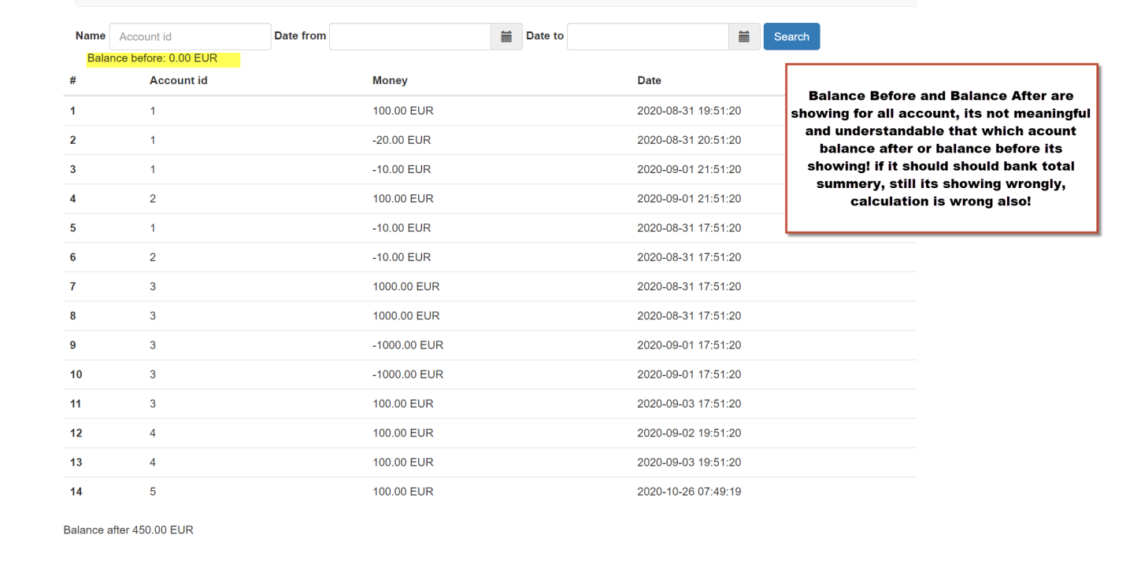 Video:**

**Issue 5:   
  
 Summary: Amount maximum digit of decimal (My SQL define value here 16:6) when inserting a few times, system crashed.   
Steps to reproduce:  
  
URL: Localhost/...  
  
Test Environment:**

Browser: Chrome 85.0.4183.121 (Official Build) (64-bit)

Screen Size: 2560 x 1440  
OS: WIndows 10  
Device: Laptop

**Expected Result:  
  
Actual Results:͓  
  
Test Data:   
  
Image: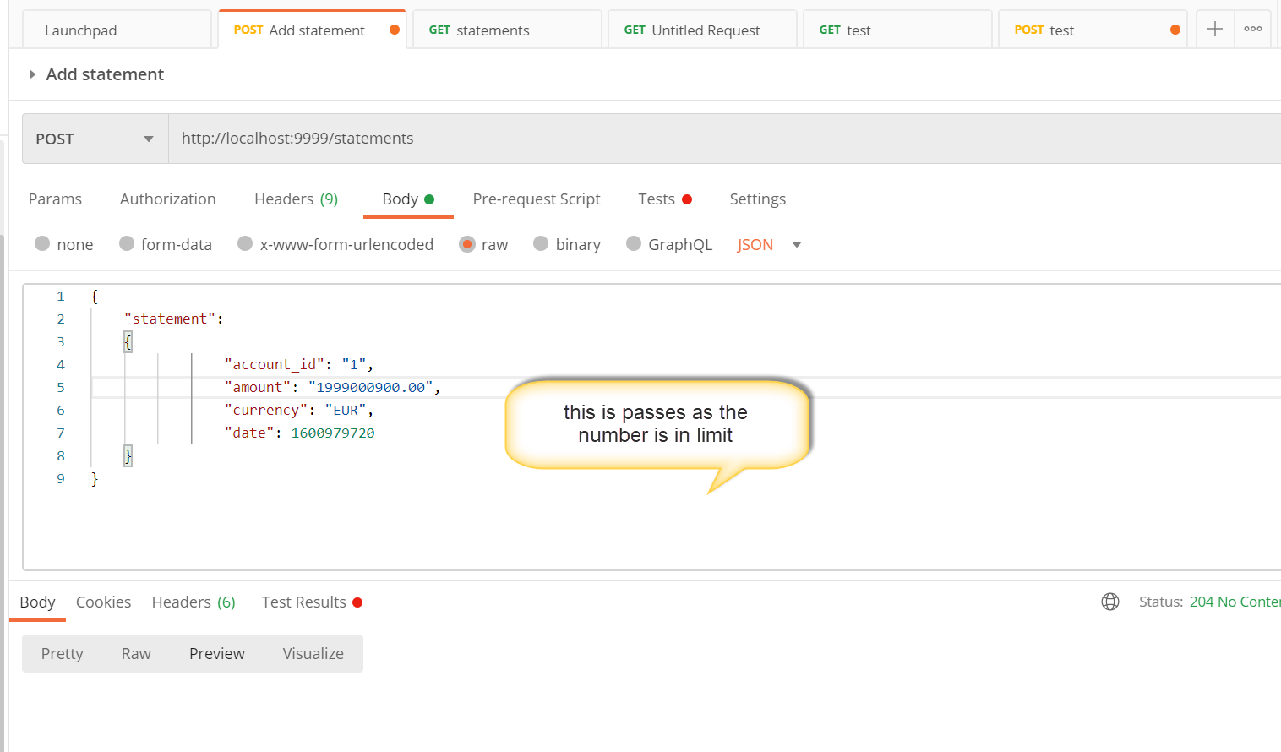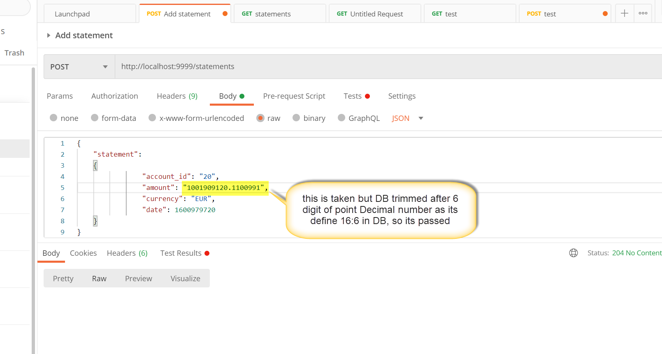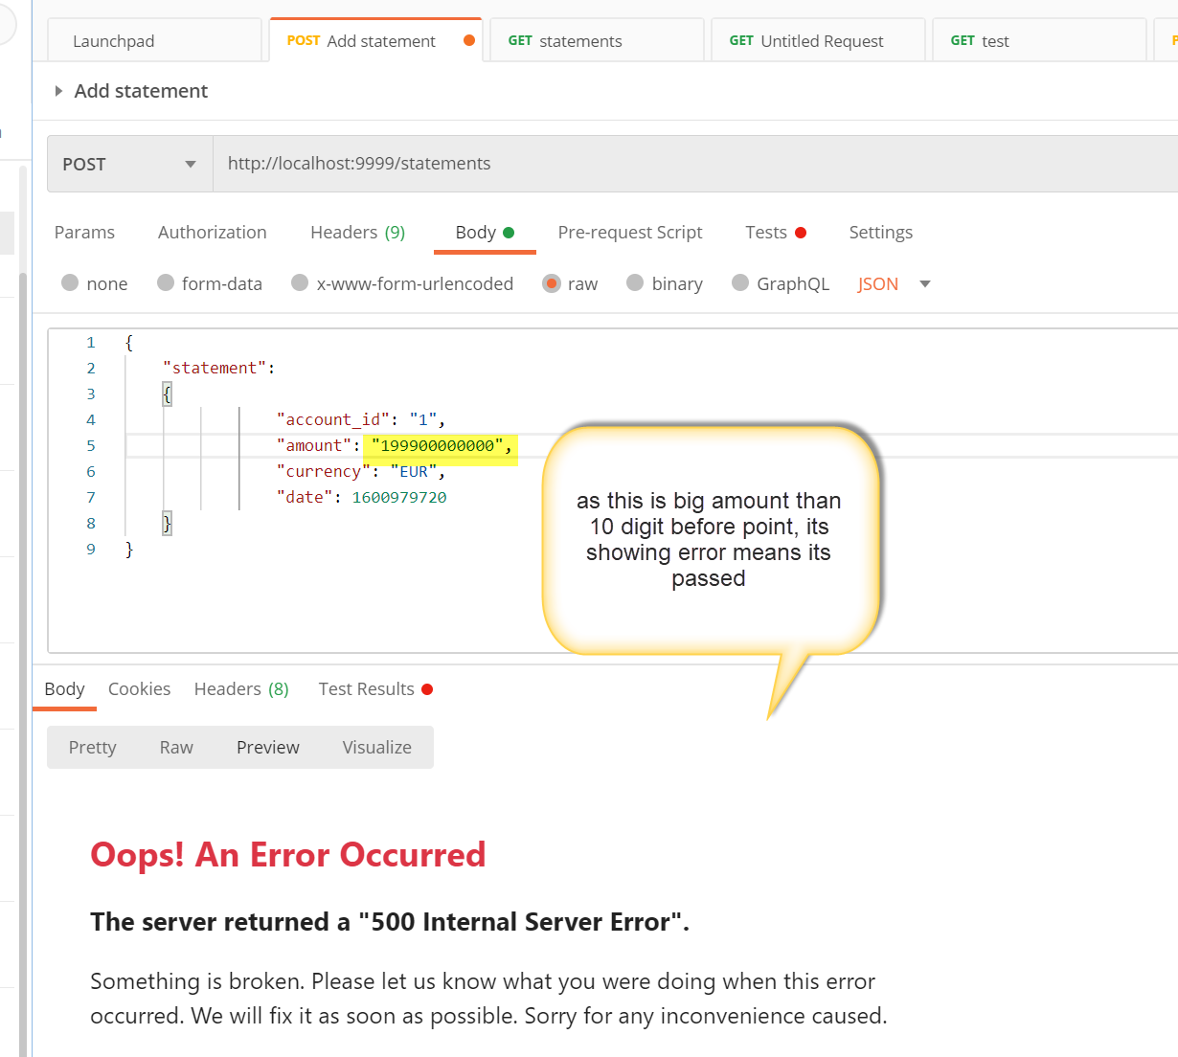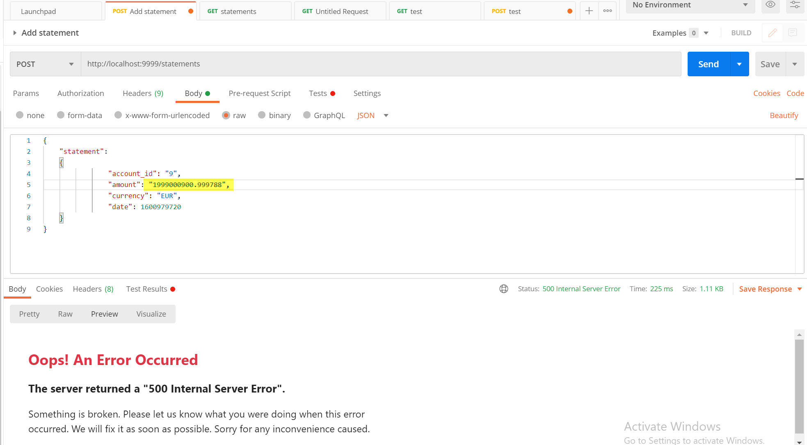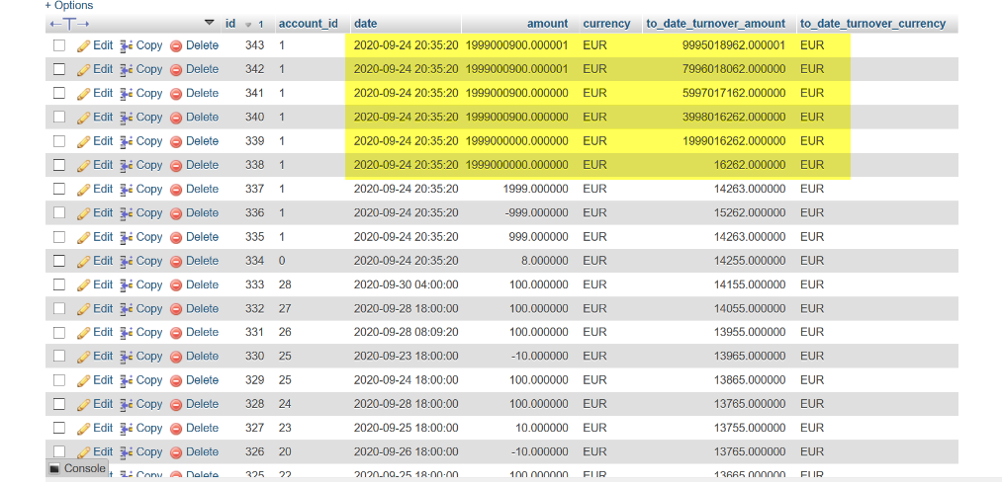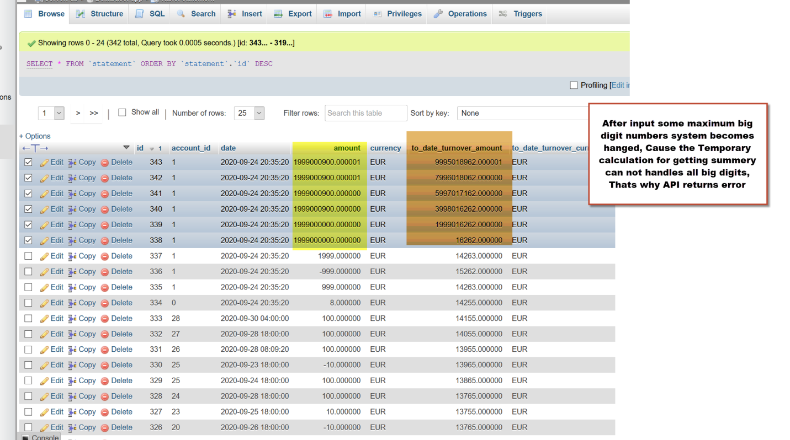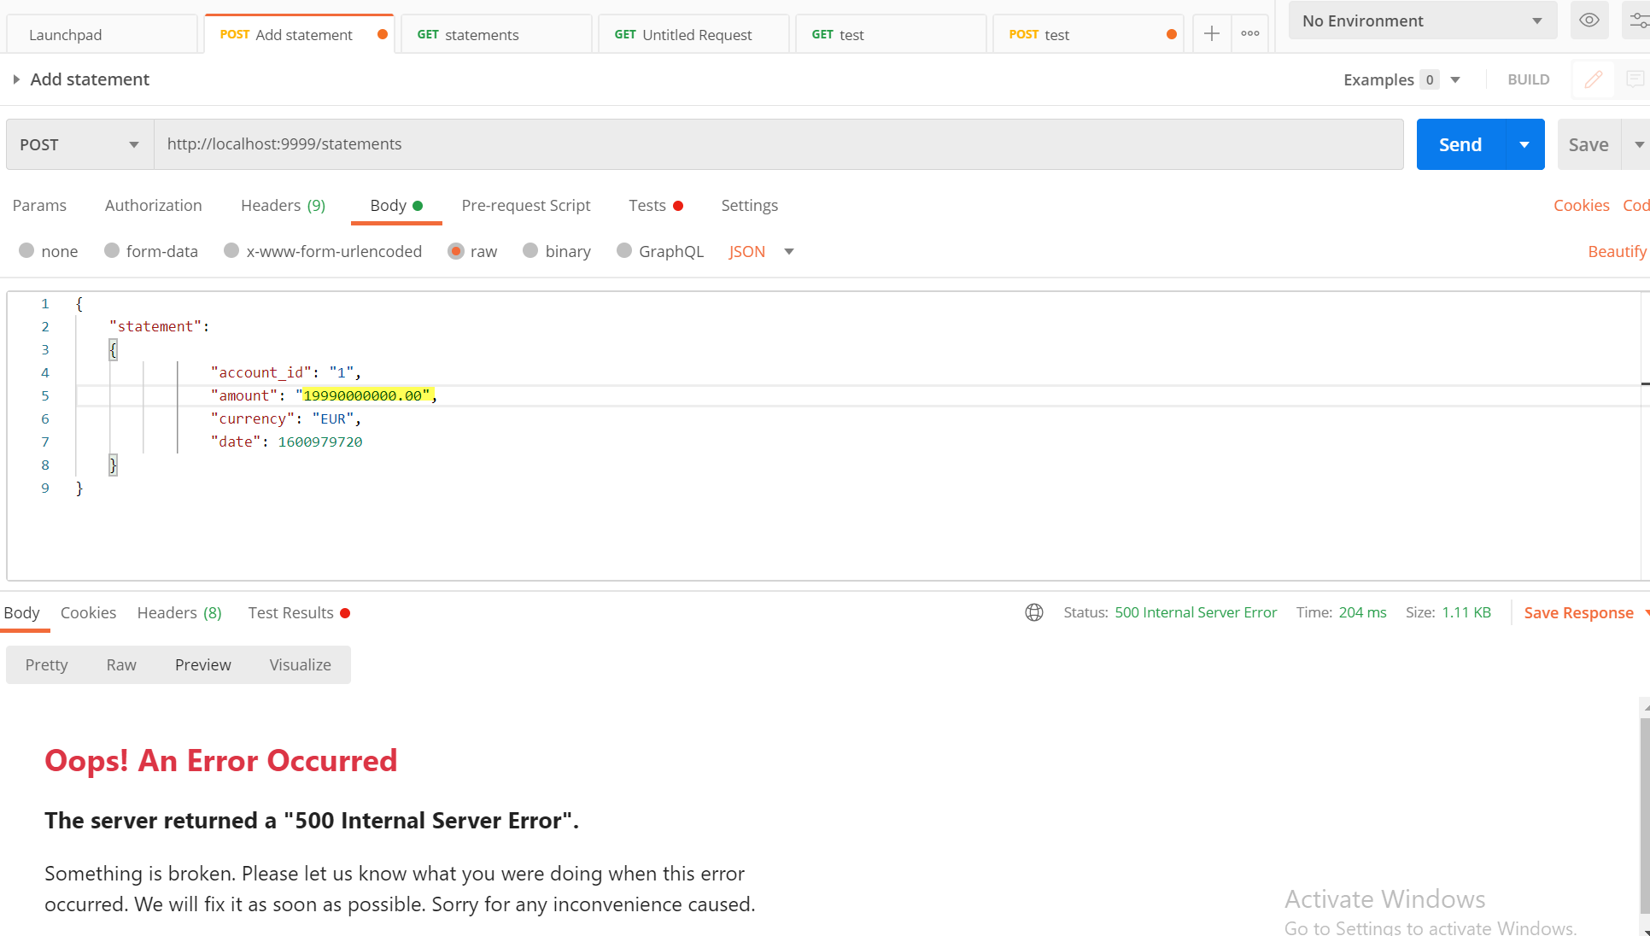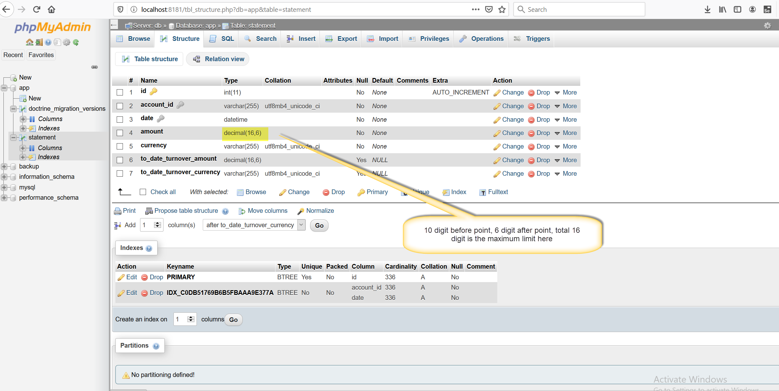 Video:**

**Issue 6:**

**When Search by Date range, Balance before and after is not updated**

**Steps to reproduce:  
  
URL: Localhost/...  
  
Test Environment:**

Browser: Chrome 85.0.4183.121 (Official Build) (64-bit)

Screen Size: 2560 x 1440  
OS: WIndows 10  
Device: Laptop

**Expected Result:  
  
Actual Results:͓  
  
Test Data:   
  
Image:   
  
  
Video:**

**Issue 7:**

**Account ID is not created automatically if not exist**

**Steps to reproduce:  
  
URL: Localhost/...  
  
Test Environment:**

Browser: Chrome 85.0.4183.121 (Official Build) (64-bit)

Screen Size: 2560 x 1440  
OS: WIndows 10  
Device: Laptop

**Expected Result:  
  
Actual Results:͓  
  
Test Data:   
  
Image:**

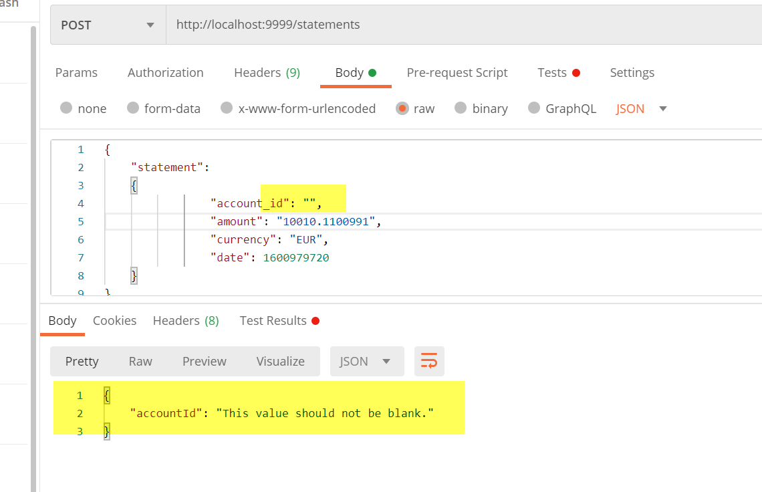

**Video:**

**Issue 8:**

**If Time zone giving in different format it should be handled in proper way and show an error message for user, so that user can understand the way of input.**

**Steps to reproduce:  
  
URL: Localhost/...  
  
Test Environment:**

Browser: Chrome 85.0.4183.121 (Official Build) (64-bit)

Screen Size: 2560 x 1440  
OS: WIndows 10  
Device: Laptop

**Expected Result:  
  
Actual Results:͓  
  
Test Data:   
  
Image:**

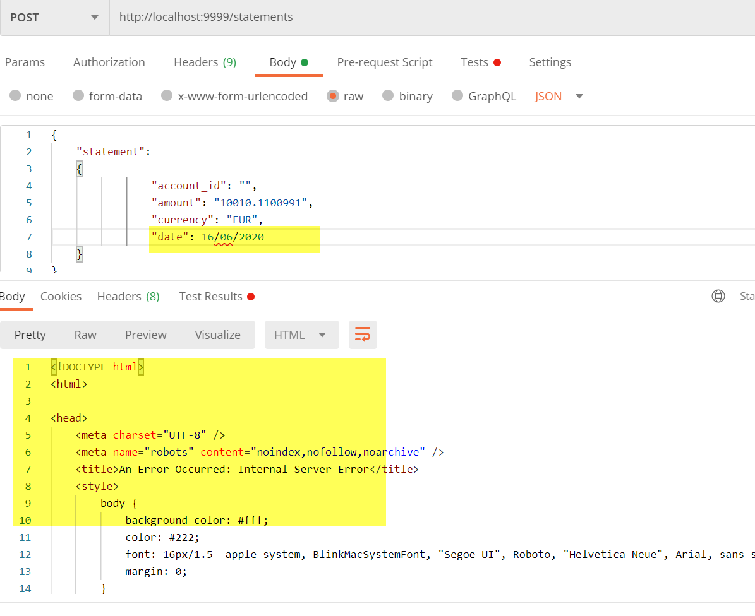

**Issue: 9:  
  
If timestamp giving wrong input, its showing abstract time, but it should not take wrong input.**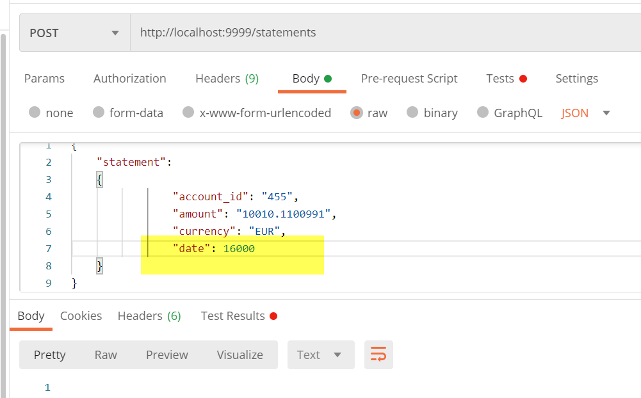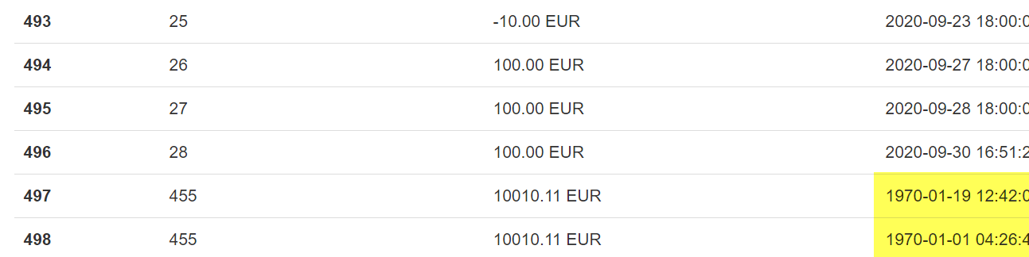

**Suggestion 1:**

1. **API can allow multiple JSON input for better data insertion, it will be helpful to insert data by writing json in a loop.**
2. **If API can not handle anything it’s better to show proper error message**
3. **API has not given some validation, which is showing 500**
4. **It’s better to add some authentication at API for security purpose**
5. **Turnover Amount digit decimal limit need to be longer than Amount decimal limit.**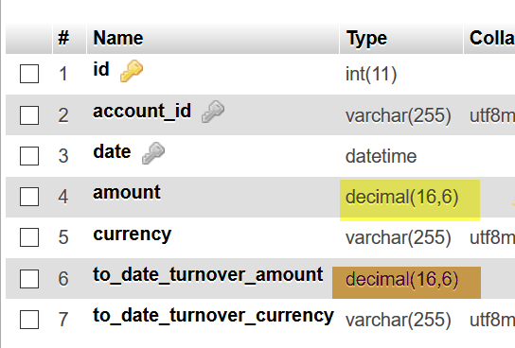
6. **Date representing and input system could be better for taking input**
7. **Before balance and Balance After the selector of the Statement page interface is not separated, it's not better design Frntend also not better for automaton development also.**
8. **API responses ERROR message could be meaningful.**